Copy the directory to your computer <https://github.com/salakrzy/HeishaMonBoth/tree/main/build_output>

Run console cmd

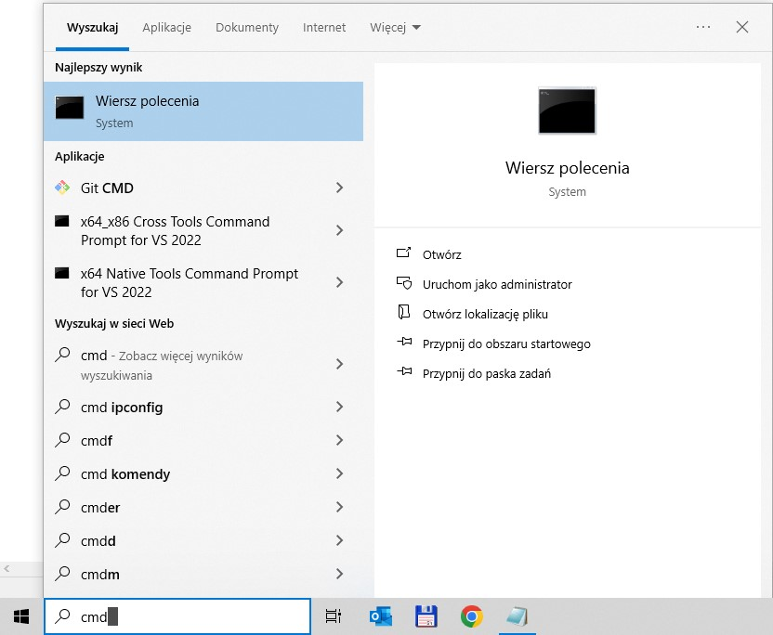

In console cmd change current directory to the directory where you copied the directory from Github using command cd D:\your_local_directory_with_copied_esptool

Close “PROGRAM” pins on the board connect USB converter to the board and to your computer.

d:\PlatformIO_GIT\Flash HeishamonBoth>esptool.exe -p COM7 flash_id

esptool.py v2.3.1

Connecting....

Detecting chip type... ESP32

Chip is ESP32D0WDQ5 (revision (unknown 0xa))

Features: WiFi, BT, Dual Core, Embedded Flash, VRef calibration in efuse

Uploading stub...

Running stub...

Stub running...

Manufacturer: 5e

Device: 4016

Detected flash size: 4MB

Hard resetting via RTS pin...

!!!!!!!!!!!!!!!!!!!!!!!!!!!!!!!!!!!!!!!!!!!!!!!!!!!!!!!!!!!!!!!!!!!!!!!!!!!!!

disconnect and connect USB to TTL converter from computer

!!!!!!!!!!!!!!!!!!!!!!!!!!!!!!!!!!!!!!!!!!!!!!!!!!!!!!!!!!!!!!!!!!!!!!!!!!!!!!!

d:\PlatformIO_GIT\Flash HeishamonBoth>flash.bat

d:\PlatformIO_GIT\Flash HeishamonBoth>esptool.exe -p COM7 --before default_reset --after hard_reset --chip esp32 --baud 921600 write_flash --flash_mode dio --flash_size detect --flash_freq 40m 0x1000 bootloader.bin 0x8000 partitions.bin 0x10000 firmware\UART_HMBoth_v3_2_3.bin 0x00391000 littlefs.bin

esptool.py v2.3.1

Connecting........_____....._____....._____.....___

Chip is ESP32D0WDQ5 (revision (unknown 0xa))

Features: WiFi, BT, Dual Core, Embedded Flash, VRef calibration in efuse

Uploading stub...

Running stub...

Stub running...

Changing baud rate to 921600

Changed.

Configuring flash size...

Auto-detected Flash size: 4MB

Compressed 18928 bytes to 13069...

Wrote 18928 bytes (13069 compressed) at 0x00001000 in 0.2 seconds (effective 809.8 kbit/s)...

Hash of data verified.

Compressed 3072 bytes to 157...

Wrote 3072 bytes (157 compressed) at 0x00008000 in 0.0 seconds (effective 1536.0 kbit/s)...

Hash of data verified.

Compressed 1102304 bytes to 665904...

Wrote 1102304 bytes (665904 compressed) at 0x00010000 in 9.4 seconds (effective 937.4 kbit/s)...

Hash of data verified.

Compressed 57344 bytes to 722...

Wrote 57344 bytes (722 compressed) at 0x00391000 in 0.0 seconds (effective 28671.9 kbit/s)...

Hash of data verified.

Leaving...

Hard resetting via RTS pin...

d:\PlatformIO_GIT\Flash HeishamonBoth>pause

Press any key to continue . . .

d:\PlatformIO_GIT\Flash HeishamonBoth>